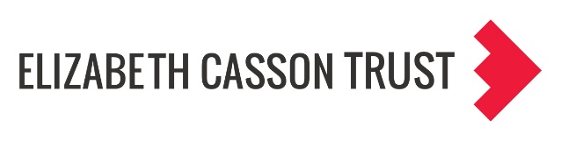

Individual Activity: Wheel of Power/Privilege
Sylvia Duckworth’s “wheel of power/privilege” is a visual representation of how power, privilege, and social identities intersect. The graphic of a wheel identifies the following social identities and respective categories:
Citizenship: citizen, documented, undocumented
Skin colour: white, different shades, dark
Formal education: post-secondary, high school, elementary
Ability: able-bodied, some disability, significant disability
Sexuality: heterosexual; gay men; lesbian, bi, pan, asexual
Neurodiversity: neurotypical, neuroatypical, significant neurodivergence
Mental health: robust, mostly stable, vulnerable
Body size: slim, average, large
Housing: owns property, sheltered/renting, homeless
Wealth: rich, middle class, poor
Language: English, Learned English, non-English monolingual
Gender: cisgender man; cisgender woman; trans, intersex, nonbinary
Individual Activity: Define Yourself
This activity encourages you to reflection on who you are, the social identities that are most significant to you, and how these connect with wider structures of power and inequality. Consider your own social positioning and the overlapping identities; in what ways do your experiences align with or differ from those of friends, colleagues, students, or the organisation you work in? How has society historically privileged certain forms of knowledge and scholarship associated with identities that sit nearer to positions of power? Whose interests have systems of power traditionally served, and whose do they continue to serve today?
Using the Wheel of Power and Privilege, reflect on how you understand and locate your own identities. Explore questions such as:
- How near or distant do your identities place you from the centre?
- How does your access to power change across different identity dimensions?
- Within your organisation, where might students, staff, administrators, be positioned on the wheel?

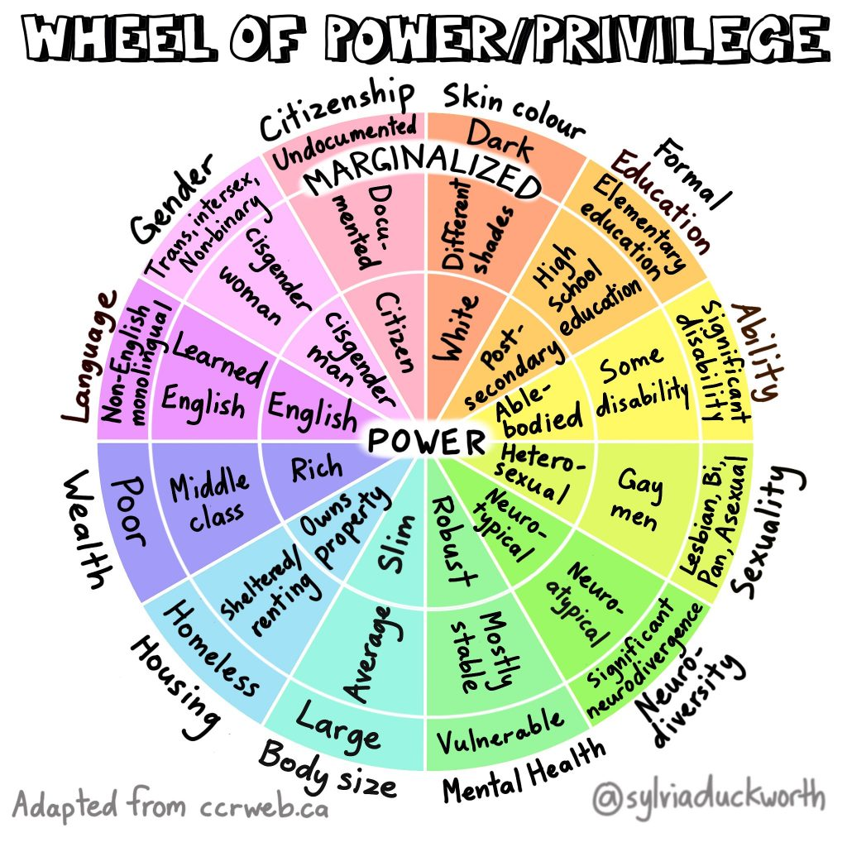

Wheel of Power, Privilege, and Marginalization, by Sylvia Duckworth. The original version comes from the Canadian Council of Refugees (CCR): https://ccrweb.ca/en/anti-oppression

