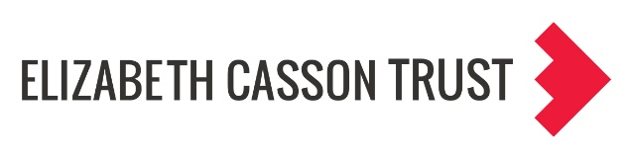

Group or Individual Activity
Watch the film and then take time to reflect individually or as a group
Suggested questions for starting reflection and discussion:
- Which microaggressions, or as Jana and Baran (2023) call them - subtle acts of exclusion, did you notice in the film?
- What was the impact of these on students?
- If you witnessed or were later made aware of these, what could you do? (think about the person who received the microaggression, the person who initiated it, and any others who were present).
- Are experiences of microaggressions familiar to you? Can you link this to your reflections from the power and privilege wheel activity? (see below)
- When someone gives you feedback on one of your microaggressions how do you respond?
- Is there any training available in your organisation for learning about microaggressions and practicing how to respond?
Further resources
Kings Fund blog - Speaking up: challenging microaggressions in the workplace. https://www.kingsfund.org.uk/insight-and-analysis/blogs/challenging-microaggressions-in-workplace
Chapter 11 Understanding and Talking about Subtle Acts of Exclusion: Activity and Discussion Guide, in: Jana, T. and Baran, M. 2023. Subtle Acts of Exclusion : How to Understand, Identify, and Stop Microaggressions. Berrett-Koehler Publishers.
Chapter 10 Responding to microaggressions, in: Sue, D.W. and Spanierman, L. 2020. Microaggressions in Everyday Life. Wiley.

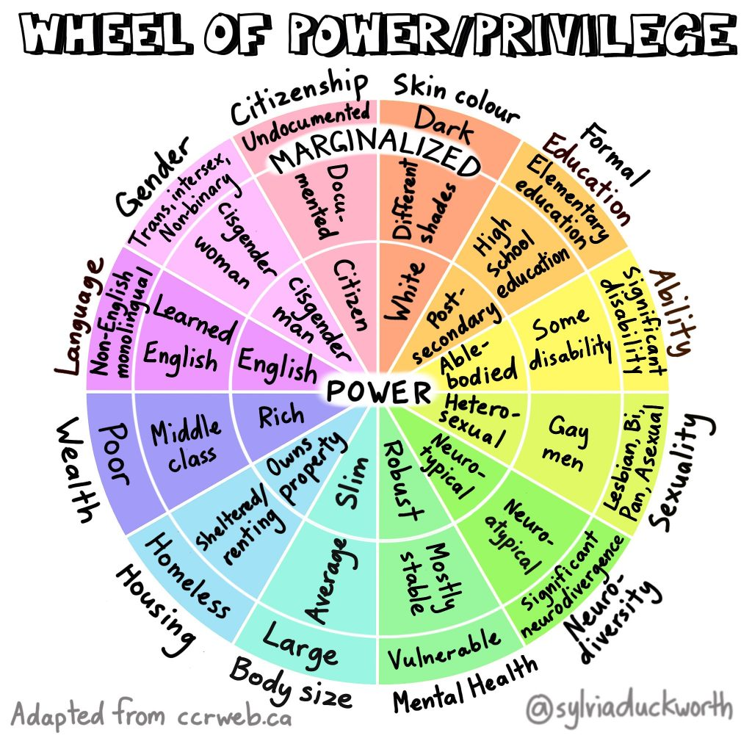

Wheel of Power, Privilege, and Marginalization, by Sylvia Duckworth. The original version comes from the Canadian Council of Refugees (CCR): https://ccrweb.ca/en/anti-oppression

