

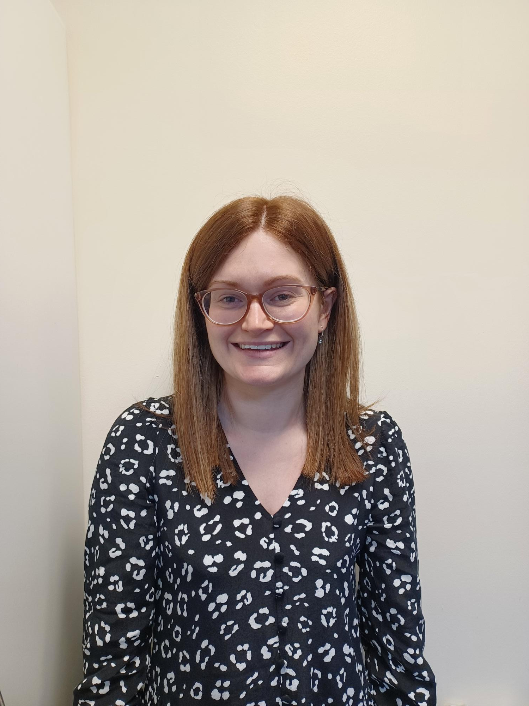

- Sarah Manson Imagery Career Story
Born and raised in Scotland, I qualified as an occupational therapist in 2015, inspired by an early encounter with an OT who demonstrated the profession’s impact on health and well-being. From the start of my career, I was drawn to working with people facing complex challenges, beginning in a community alcohol and drug recovery service before moving into secure inpatient mental health. Here, I gained invaluable training, mentorship, and the ability to think creatively in my practice.
I have faced challenges in sharing the impact of OT, navigating important conversations and developing leadership and people management skills. However, training, supervision and coaching support has been instrumental in overcoming these obstacles. I stepped into my first specialist OT role in an emerging role within an inpatient setting, where I developed advocacy skills and a deeper understanding of OT’s influence.
A personal leadership programme encouraged me to take another new opportunity, leading to a role as the sole OT in an ARBD multidisciplinary team, where I strengthened my collaborative and quality improvement skills. Two years ago, I embraced a new challenge as an advanced practitioner in primary care, a role I love for its continuous learning and evolving opportunities in early intervention. My journey has reinforced the importance of stepping out of my comfort zone, leveraging mentorship, and embracing new experiences. Looking ahead, I am excited to continue advancing occupational therapy.

