

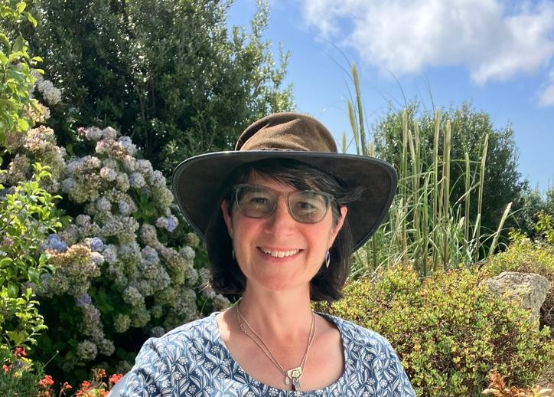

- Rachel Rickayzen Written Career Story
I first considered studying OT during my teens, but then changed tack to study Psychology. My favourite module was Occupational Psychology; I don’t think I should be that surprised, in retrospect! I eventually went back to study for a degree in OT in my mid 40s, following a varied career (which always had some form of occupational link), and after taking time out to undertake caring responsibilities for 3 generations of my family. I suppose that lots of these care-giving experiences, which focused on living a good life following illness and injury, prompted me to take a leap into the profession.
After qualifying, it was impossible to find a band 5 role which enabled me to work part time around the kids and so I went into a community mental health charity, on a maternity cover contract. The freedom to work with clients in this post was wonderful; for example, we weren’t restricted by the number of sessions we could offer. If the client required ongoing support, they received it. We also had a day centre facility where staff co-ran groups with volunteers who had lived experience of mental illness. I look back on this time with enormous fondness and learnt so much from my colleagues, volunteers and clients. At the end of the contract, I went into a psychiatric setting, but after 6 months, this was cut short by the Covid pandemic as I had to shield to keep a family member safe. During this time, I completed my life coaching training and started working remotely for a university wellbeing service as a Mental Health Practitioner. I have worked within student mental health ever since.
I work in a lovely, small team, but I am the only OT. This, along with not having access to clinical training, can be a challenge. I endeavour to keep up with CPD but I miss having fellow OTs to discuss things from our professional perspective. My personal interests mean that I would rather focus on enhancing wellbeing and preventing illness, but roles with this focus are hard to find.
I love working 1-1 with students, where both my OT and coaching skills are utilised. I volunteer as a bereavement supporter, and I often find myself wearing an unofficial OT hat when supporting bereaved people. I have also recently started doing some mentoring for the OT profession and I am really enjoying this.
I would love to see a greater public understanding of OT. I am often frustrated when I see new articles which focus on wellbeing, rehabilitation or other topics which are so intrinsic to OT, but find that we are not mentioned at all!
The beauty of OT is that its application is universal, and I hope that its use increases in illness prevention/wellbeing promotion and non-clinical settings as well as in more established services. We need to keep spreading the word and generating greater public awareness of our profession at policy level; I hope that RCOT can spearhead this for OTs.

