

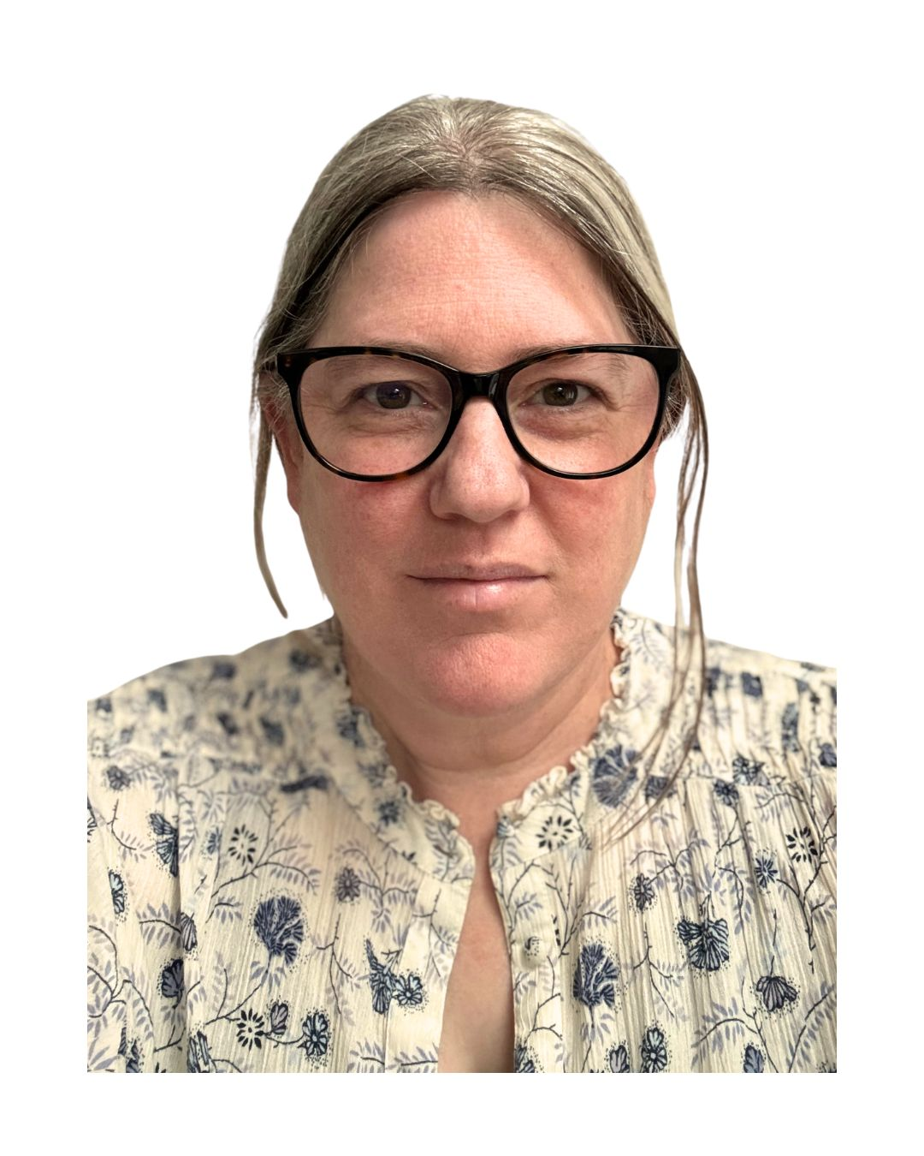

- Lynsay McFarlane-Shaw audio transcript

Lynsay McFarlane-Shaw | OT Supervisor - Independent Occupational Therapist | 30 Whitmore Road | Harrow | HA1 4AB | Telephone: 07757 308 706 | E-mail: Lynsay@OTsupervisor.com |HCPC No: OT24756

I’m Lynsay, an OT supervisor and independent OT.
I chose to be an OT after a sibling had a motorbike accident and a life-changing injury. Their experience and rehab helped me appreciate that people need person-centred support, with the appropriate occupations to engage in and delivered in the best environment for them. Something that stayed with me throughout my career.
Thirty years on, I am still a practising OT. My clinical background is working with CYPF.
I spent 20 years working in the NHS and the last 10 in independent practice, which I continue to do. I also have an online OT supervision business, working with OTs in independent practice, diverse settings, the NHS and student OTS. I provide long-arm external supervision through 1:1 and group sessions. During my PG cert in clinical supervision, I developed the long arm model of occupational therapy supervision, which I am preparing for publication. I am now developing online training on supervision skills to help therapists enhance their skills in this area.
When I reflect on my career, I think key challenges and learnings have been managing the demands of the role as an OT, working within pressured services, understanding the pressures, their impact on team and relationship dynamics, and the resulting impact of the services provided to clients.
I have experienced burnout. For me it was a combination of both work and life events. I wish I had reached out to an external OT supervisor at this time. It may not have changed my career decisions, but it would have helped my overall wellbeing.
When I started a new chapter in my career and entered independent practice, I was lucky to have other colleagues in this area. We supported each other in learning the business side of independent practice. It was a period of significant growth, one that can feel isolating if you don’t have support in place.
When I think of achievements over my career, I would be the successes of others, the CYPF that I have worked with. I love hearing feedback from families about the lasting impact of OT intervention on the quality of their life. Then all the fantastic OTs I have supervised over my 30-year career. Seeing the success of others through providing person-centred OT supervision that supports clinical, OT business and personal development is amazing. Developing a long-arm model of OT supervision has also helped bring my ideas and passion for OT supervision together; publication is a future goal yet to be achieved.
If I am to leave you with a thought for your future career, to would be to stay connected with others. Engage in OT supervision in your workplace but don’t be afraid to invest in supervision that is personalised to your needs, as these needs change across your career. Be honest about your occupational balance and get the support you need; OT yourself a little and ensure your career planning supports your professional, personal and business skills. And finally, Network, there are so many inspiring OTs doing amazing things. And be brave and follow your OT dream.

