

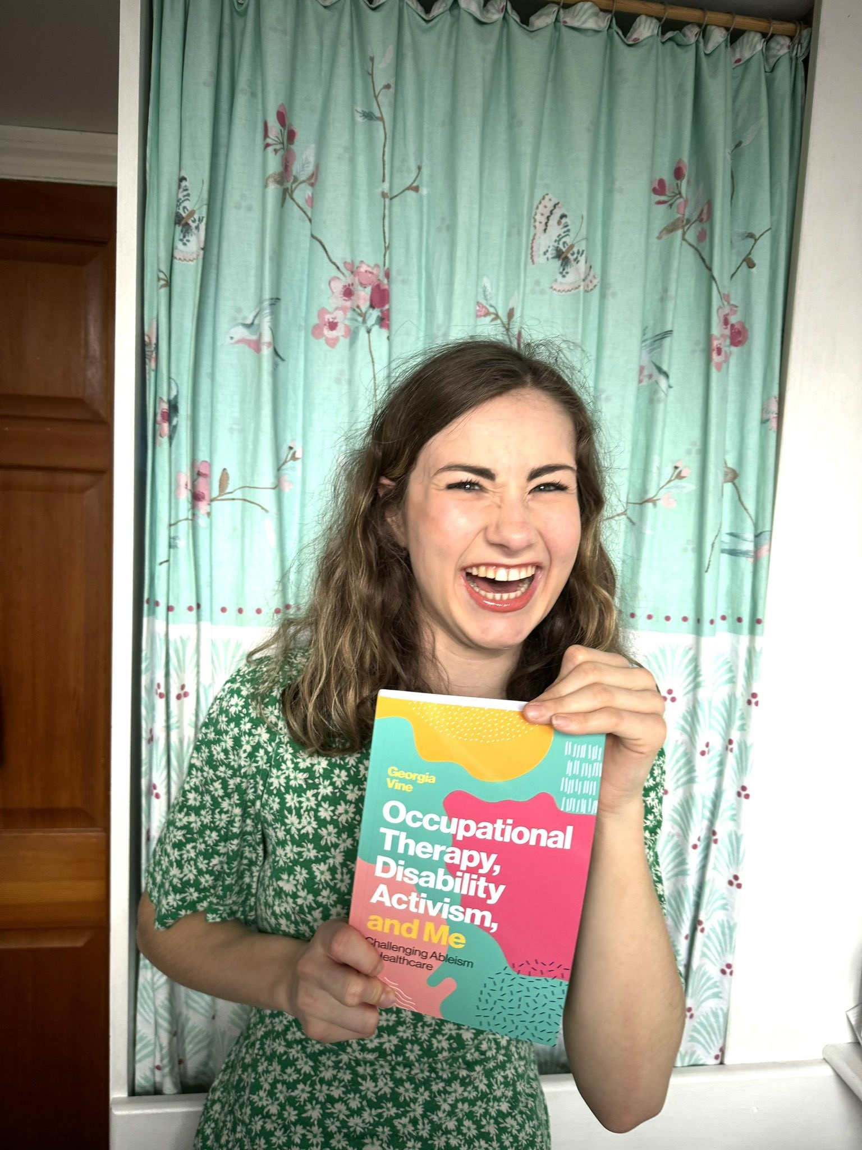

- Georgina Vine Written Career Story

What has your occupational therapy career story been to date?
During my studies I developed my award-winning blog ‘Not So Terrible Palsy’ which explored my experiences as a disabled OT student and analysed the barriers I faced during my professional training. From this I then found my passion for challenge ableism in the profession to better the future of healthcare for those we serve and become a founding member of AbleOTUK. My lived experience of disability is the biggest tool in my career and is something I use every day whether this be through my activism work or in my role as a Graduate Teaching Assistant.
What have been the main challenges that you have faced in your occupational therapy career to date?
The main challenges I have faced is the assumptions I got just before I started the occupational therapy course and during some of my placements. My physical abilities along we my speech impairment meant I didn’t fit the picture of the ‘standard OT’ and this caused questions. I am not naive to the fact that my disability means that I face additional challenges, but these can be managed through reasonable adjustments. If we can be innovative around creating access to those we serve, then why can’t we for our colleagues? Yes, I don’t want to be ‘OT’ed’ but the skills of OT’s can still be used to create an accessible environment for everyone within the profession.
What are your main achievements and highlights of your occupational therapy career to date?
In 2024 I released my debut book ‘Occupational Therapy, Disability Activism and Me’ where I critically explored my experiences as a child under occupational therapy services right through to my first job within the profession to challenge and highlight my ableist experiences. This is something that I never dreamed of doing so to be able to do this so early on in my career is something I will never comprehend.
What hints and tips would you offer to other Occupational Therapists to help their own employability and career stories?
Don’t be afraid to be your authentic self, without embracing my own personal skills along with my skills as an OT I wouldn’t be where I am today. It sounds very cliche, but we don’t need a profession full of the same OT’s, we need a profession full of unique OT’s that is diverse and most importantly can represent those who we serve to challenge occupational justice.

