

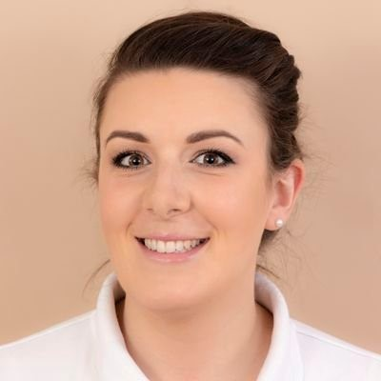

- Alice Gair audio career story transcript

My name is Alice. I'm a community paediatric and acute neonatal occupational therapist working at advanced level. In my clinical roles, I work in a mainstream school as part of a service level agreement with children from nursery age up through to year six in an area of great deprivation and where families are impacted by multiple health and healthcare inequities. In my neonatal role, I work in a large level three neonatal unit within a tertiary hospital, seeing some of the most poorly infants in our region, either born too early or with complex medical needs. I'm also Allied Health Professional or AHP Clinical Fellow, working strategically in my region to support regional and national initiatives to grow, develop and retain our AHP workforce. I'm hugely passionate about equality, equities and diversity. And enabling people to realise their full potential and their goals, particularly if they feel disadvantaged. This was amplified after having my own children, my first who has a physical disability and other lifelong health needs, and the added impact that this has had on my mental health. My recent experiences have consolidated why I became an OT, particularly around our uniqueness in bringing physical and mental health together. My career has been quite varied. to date. So initially I kind of consolidated my skills as a community adult learning disability OT for around a year before moving into paediatrics, which was my dream role to get into. It was at this point I started to get more involved in quality improvement initiatives and was successful in various different funding streams. and to be able to lead on some exciting service improvements, particularly around innovation and sensory support for families. It then became a bit more of a portfolio career. I moved into neonatal occupational therapy to upskill into this area, but also help introduce a service offer where neonatal OT previously hadn't been set up. and at the same time, or around the same time, started to get involved with some other more strategic work and opportunities. So I was part of the NHS, or I'm part of the NHS England
Clinical Entrepreneur Programme. I am currently an AHP fellow, as I've mentioned, which is more around strategic workforce planning and intervention. And I'm actually also working as an apprentice or I am currently an apprentice with the Healthcare Professions Council and getting some experience and exposure from that point of view. One of the biggest challenges in my career has been more recently juggling the occupational demands of being a mother and pursuing a career in a way that meets my own goals, both at home and at work. And I can't say that I've necessarily overcome them, but rather attempted to work with them. I recently joined a 10-year graduation get-together with the OTs I trained with, which led to some fairly reflective discussions about burnout. And we mulled over the literature and the anecdotal evidence base. about the power of purpose and value and essentially it felt like we were OTing ourselves a bit actually, discussing what meaningful activity was for each of us and that actually it isn't necessarily about the workload that contributes to burnout but what your perceived value is in your role, what your own goals are and how you work within that team. So I guess in a way, inadvertently developing a bit of a portfolio career that certainly seems to be kind of gaining a lot of attention at the moment has been a way of me keeping a handle on something that feeds
my creative and innovative tendencies in a flexible and autonomous manner. There are multiple highlights in my career. There's lots of things that I'm proud of, but also feel incredibly lucky to have been able to land so many other opportunities that I have had. It's really important for me to mention here that it's not been without the support of lots of wonderful OT colleagues, leaders and friends, as well as other members in our AHP and MDT communities. And I'd like to thank anybody that's listening in relation to that. But I guess when I really do reflect and put things in perspective, one of my biggest personal achievements has been to continue to pursue my OT dreams, despite facing significant personal challenges, particularly around occupational balance and becoming a working mum and in light of having a child with lots of different needs and the impact that that had on me. or has on me. It's also made me less afraid of showing and talking about my own vulnerabilities. I recognise the importance of that and the strength in it. And actually I've learnt this safety from the modelling and examples from other minority groups and I can understand and recognise that this can be hard and it's often met with cultures that are not used to this mindset. Yeah, I think that's probably one of my biggest highlights, actually, is seeing the value in that and recognising how much work needs to be done. Despite the challenges that I have had, I've been able to enjoy multiple highlights, particularly around quality improvement and innovation, such as being able to actually work outside the world of the NHS a little bit and outside of operational level work. And just to finish in regards to hints and tips that I would offer OTs to help with employability and career stories. The first thing that I think is really important is to know your why for what you're doing. I think this often resonates closely to your own lived experience. People don't always recognise this. Knowing and connecting to your purpose is proven to lead to greater success in both personal and team goals. And the second point would be to recognise that you're the master of your own future and to be creative and open-minded about how you achieve your goals. And just because it hasn't been done in a certain way before, doesn't mean that it's not possible. And then finally, it would be to be and to love your authentic self and know that you can achieve what you set out to achieve.

