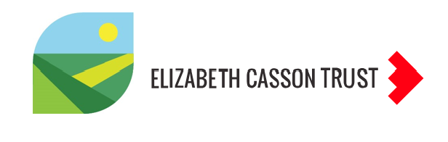

- Work Skill Development Framework

The Work Skill Development Framework (Bandaranaike, 2018) was originally developed for students, but provides a useful framework to reflect on your current work role and how autonomous you are in a range of work skill facets, that are very relevant to you as an Occupational Therapist.
It is important to consider where you are within your current role to establish where you are now. It will highlight areas that you excel in as well as areas where you could develop yourself further within the workplace. The Work Skill Development Framework activity complements the Capitals reflection and SWOT analysis within this Where am I now? section of the EACHOT which focused more of a generic helicopter rather than role specific reflection of your current employability.

Bandaranaike, S. (2018). From Research Skill Development to Work Skill Development. Journal of University Teaching & Learning Practice, 15(4). https://doi.org/10.53761/1.15.4.7 Research Online is the open access institutional repository for the University of Wollongong. For further information contact the UOW Library: research-pubs@uow.edu.au

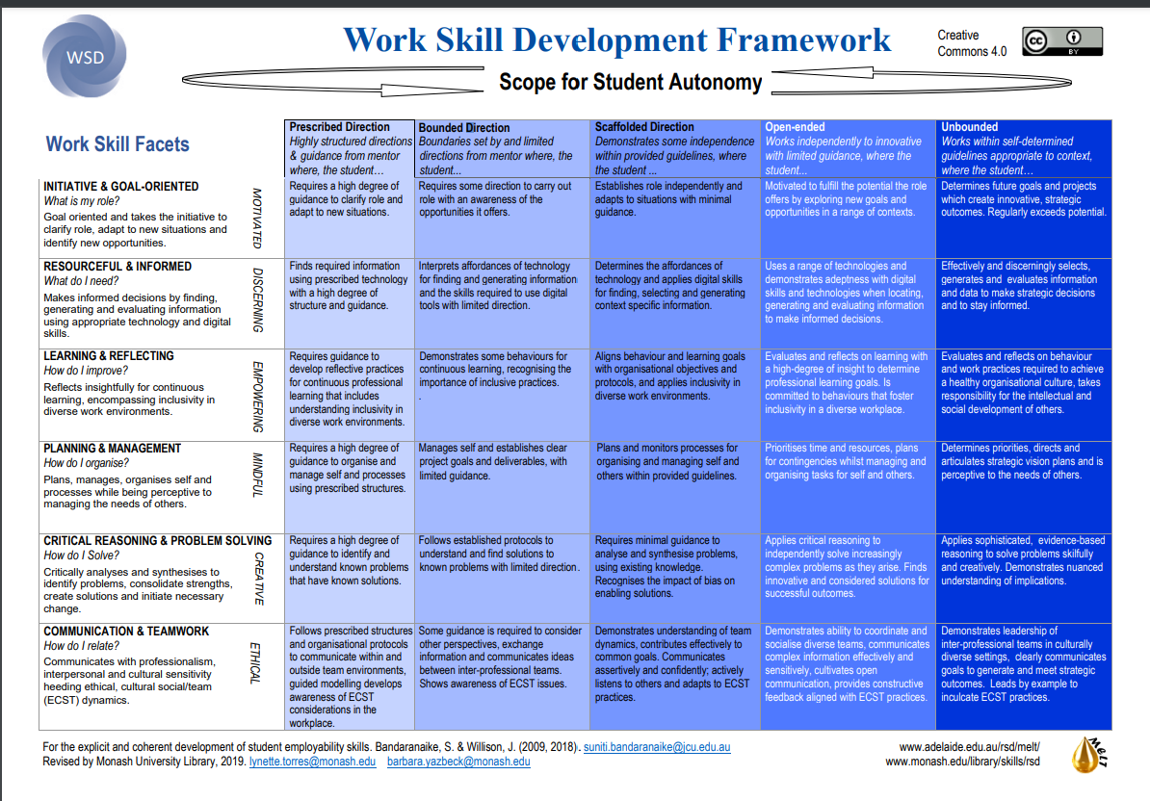

The Work Skill Development Framework has been adapted below to provide an opportunity for you to reflect and evidence where you are now within your current role, in relation to the different facets of work skills. This reflection will provide you with a springboard from which to consider and plan your future.

Reflection on your current role within an adapted work skills development framework
Fill in the relevant boxes below to evidence your level of autonomy for a range of work skills within your current role. Once completed – reflect on where there may be room for personal or professional development within your current role.
Date of reflection:
Categories | Level of autonomy
Categories | Highly structured and directed by others | Bounded work but with limited direction from others | Scaffolded direction with some independence within guidelines | Open-ended independent working with very limited guidance | Unbounded autonomous working appropriate to the context
How do I act in my current role – I am goal oriented and takes the initiative to adapt to new situations and identify new opportunities.
What I need to know in my current role – I make informed decisions by finding, generating and evaluating information using appropriate technical and digital skills.
How I improve myself in my current role – I reflect insightfully for continuous learning, encompassing inclusivity in diverse work environments.
How I organise myself in my current role – I plan, manage, organise self and processes while being perceptive to managing the needs of others.
How I solve problems within my current role – I critically analyse and synthesise to identify problems, consolidate strengths, create solutions and initiate necessary change.
How I relate to others within my current role – I communicate with professionalism, interpersonal and cultural sensitivity, heeding ethical, cultural social/team dynamics.

