

- Capitals and employability video transcript
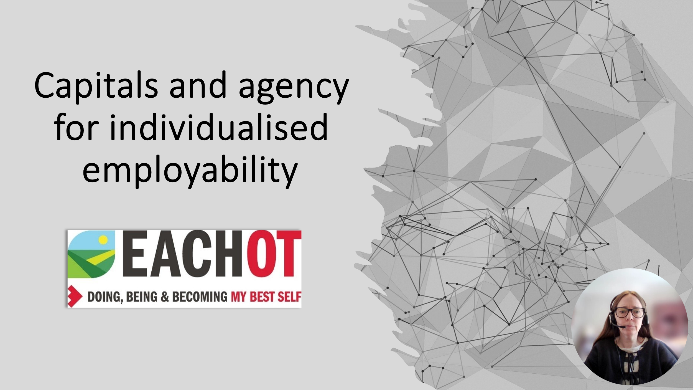
This presentation is an opportunity to explore the capitals-based model and look at how you can develop your agency for your own individualised employability. Employability is a life-wide and life-long journey.



Employability itself is a process of personal and professional development throughout your career, with employment outcomes on the way. Employability has been the focus of higher education for many years, but a lot of the principles that have been applied within graduate employability can be applied to ourselves as qualified occupational therapists. And employability has now evolved to become much more focused on a capitals-based approach, which helps facilitate individual agency throughout an individual's employability and career journey.
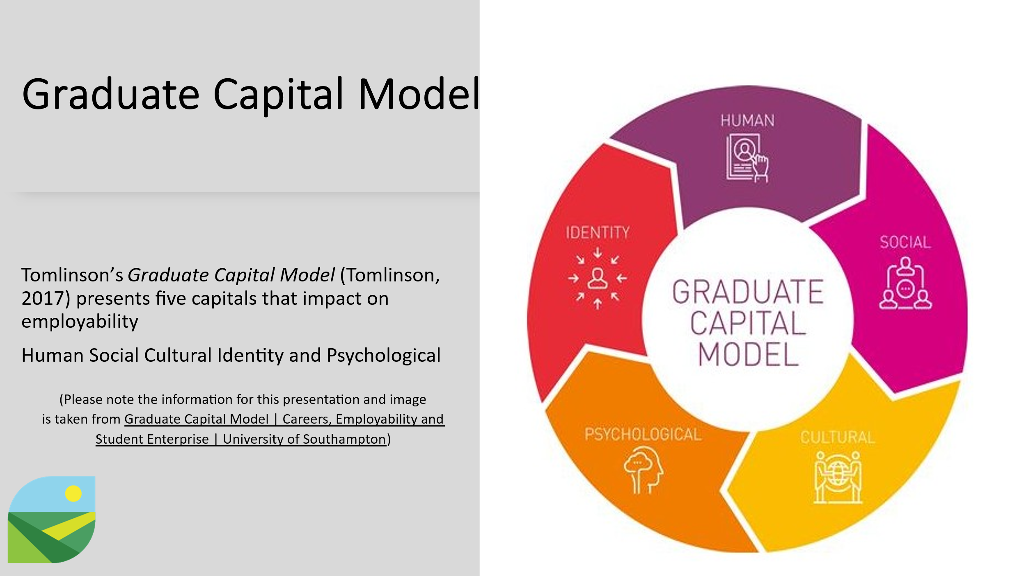
So I'm going to present the Graduate Capital Model to you now, taking into account the fact that these principles can be applied to us at any point of our careers. So Tomlinson has presented the Graduate Capital Model where there are five capitals that impact on employability. These are human, social, cultural, identity and psychological. I've put the link to the website where these are expanded upon further and can be found here Graduate Capital Model | Careers, Employability and Student Enterprise | University of Southampton

Human capital is your knowledge and skills about yourself and the occupational therapy working landscape. It's your ability to identify career opportunities within occupational therapy. How can you translate your knowledge and skills to realise occupational therapy career opportunities that you have identified?

Social capital is your knowledge and understanding of the landscape in which you are working. Who are the key individuals within your clinical, educational, research or leadership area? What existing networks have you got within your area of interest? What is your online network and presence and how can you promote yourself within your networks?

Cultural capital is your knowledge, understanding and appreciation of an individual's culture, the working culture of occupational therapy, the organisational culture within which you work or may want to work. How could you add value through your knowledge, understanding and appreciation of culture?

Identity capital is looking at who you are, what can you bring to the workplace and what do you want to achieve through your occupational therapy career? What are your employability resources and how can you evidence these? Where are the gaps in your employability resources? What is important to you, values and behaviours wise? What motivates you with your work? What progress have you made to date and what have you learnt from those experiences? What types of jobs do you think fit your needs personally and professionally?

Psychological capital relates to the changing work environment that we're working within. It's constantly changing and we do need to be able to adapt and to be flexible within that environment. How well do you manage uncertainty within the workplace? What strengths or strategies do you need to develop to mitigate the impact of uncertainty on yourself? What contingency planning can you have for your career? Do you have a plan B?
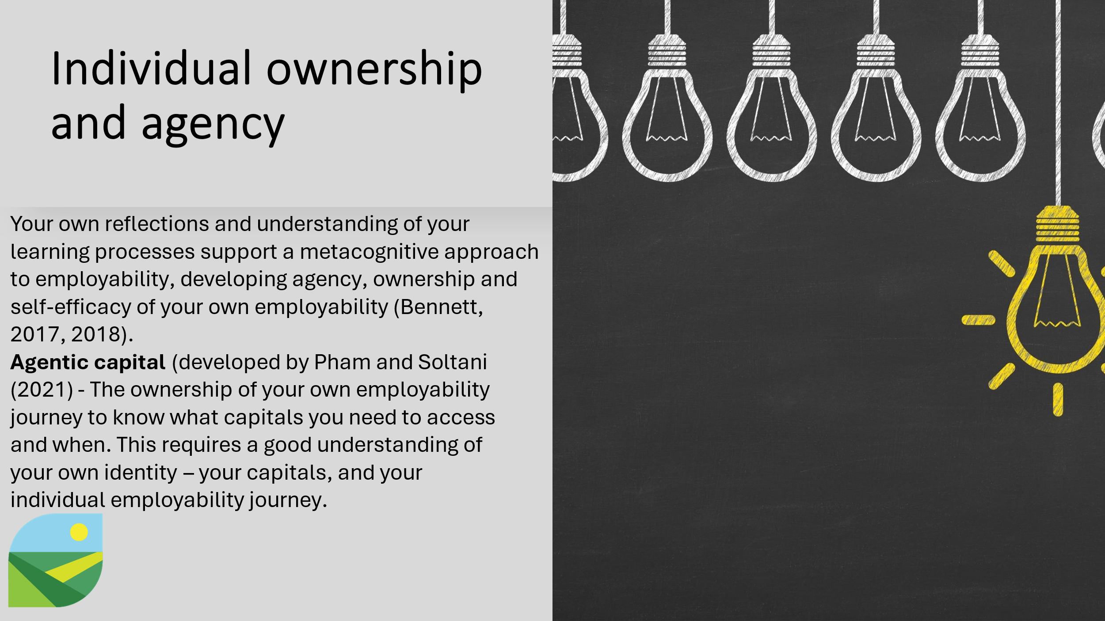
Individual ownership and agency relates to your own reflections and understanding of your learning processes, which supports this metacognitive approach to employability, developing agency, ownership, self-efficacy of your own employability. Pham and Soltani added agentic capital to the other five capitals presented previously. This relates to the ownership of your own employability journey, to know what capitals you need to access and when. This does require a good understanding of your own identity, your capitals and your own individual employability journey.
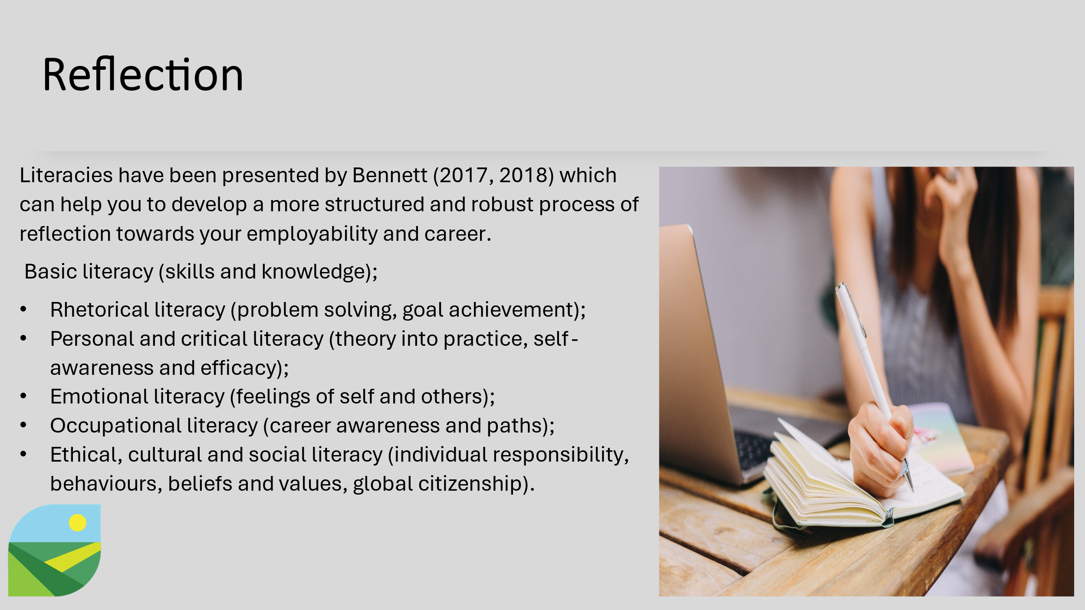
Reflection is so important in your employability journey and Bennett has presented some literacy which can help you develop a more structured and robust process of reflection towards your employability and career. So there's basic literacy, skills and knowledge, but also rhetorical literacy, such as problem solving, goal achievement, personal and critical literacy, putting that theory into practice, your self-awareness and efficacy, emotional literacy, such as feelings of yourself and others, occupational literacy, career awareness and paths, ethical, cultural and social literacy, individual responsibilities, behaviours, beliefs and values, and global citizenship.
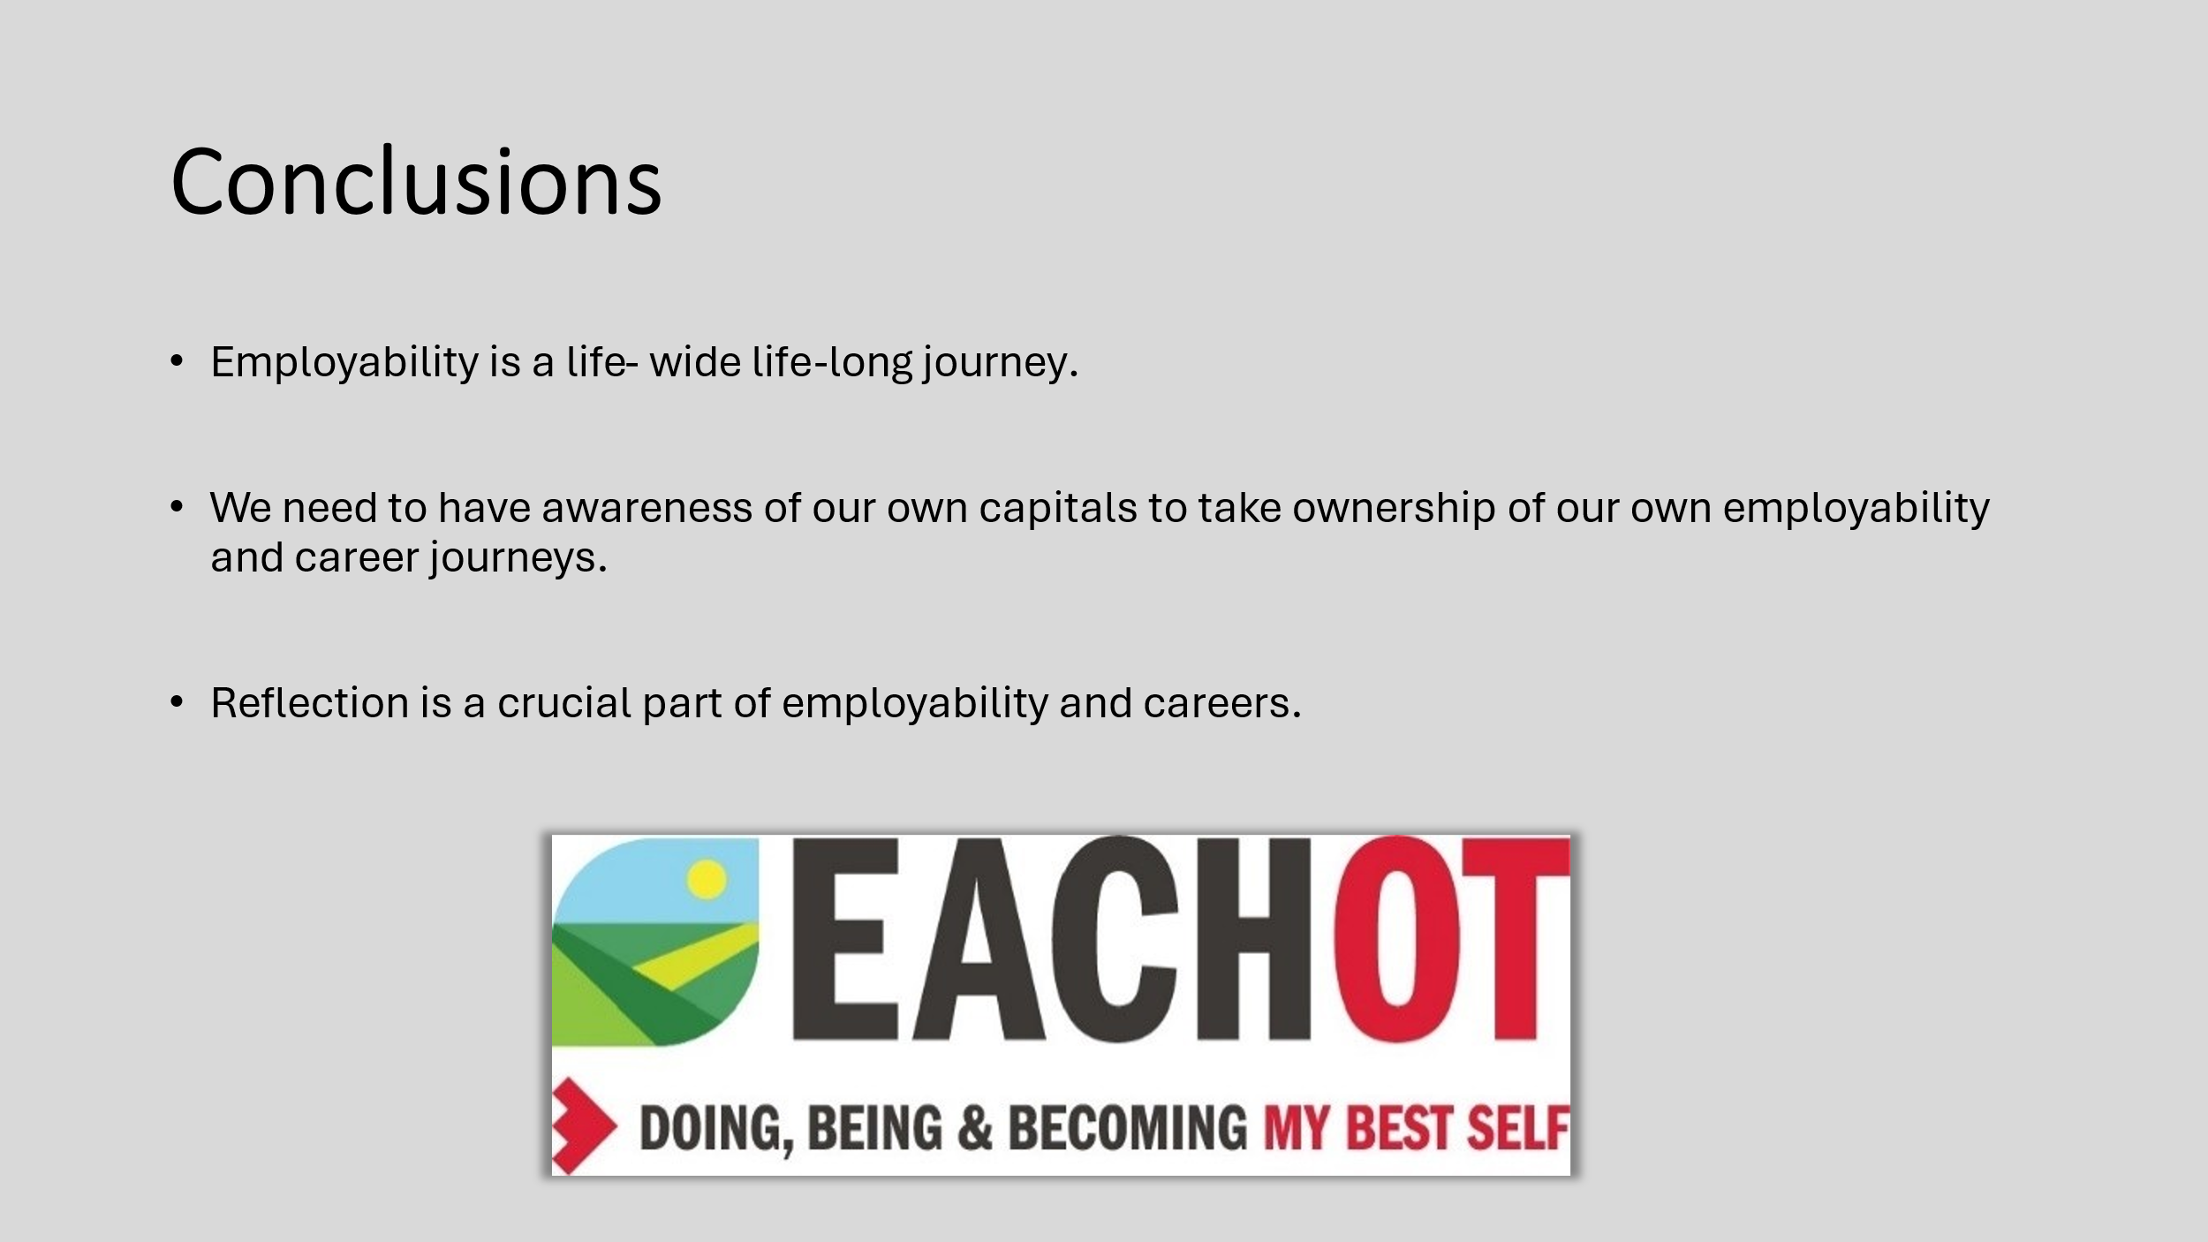
So to conclude, employability is a life-wide, lifelong journey. We need to have our own awareness of our own capitals to take ownership of our own employability and career journeys. Reflection is a crucial part of employability and careers. Please find a reference list here where you can refer to any of the evidence that I've presented within this presentation.
References
- Bennett, D (2017) Metacognition as a graduate attribute: Employability through the lens of self and career literacy. In Huda, N., Inglis, D., Tse, N., & Town, G. (Eds.), Proceedings of the 28th Annual Conference of the Australasian Association for Engineering Education (214-221). Sydney, December 10-13
- Bennett, D (2018) Embedding employABILITY thinking across Australian higher education. Submitted July, 2018. Canberra: Australian Government Department of Education and Dawn Bennett 54 Training. Retrieved from https://altf.org/wp‐content/uploads/2017/06/Developing‐EmployABILITY‐draft‐fellowship‐report‐1.pd
- Pham, T., and Soltani, B. (2021) Enhancing student education transitions and employability – From theory to practice. London: Routledge.
- Taylor, L. (2016) How to Develop Your Healthcare Career: A Guide to Employability and Professional Development, John Wiley & Sons, NJ.
- Taylor, L. (2023) Constructing online work-based learning placements – approaches to pedagogy, design, planning and implementation. New York and London: Routledge.
- Tomlinson, M., and D. Jackson. (2021) Professional Identity Formation in Contemporary Higher Education Students. Studies in Higher Education 46 (4) : 885–900. doi:10.1080/03075079.2019.1659763.
- Tomlinson, M. (2017) Forms of Graduate Capital and Their Relationship to Graduate Employability. Education + Training 59 (4) : 338–352. doi:10.1108/ET-05-2016-0090.

